CHAPTER 2: Getting into genes

Worksheet 2.1

Genes and chromosomes
Answers

Humans and cats
1. The following diagrams show the chromosome map of a human and a cat. The human chromosomes are shown as single stranded and the cat chromosomes are shown as double stranded.
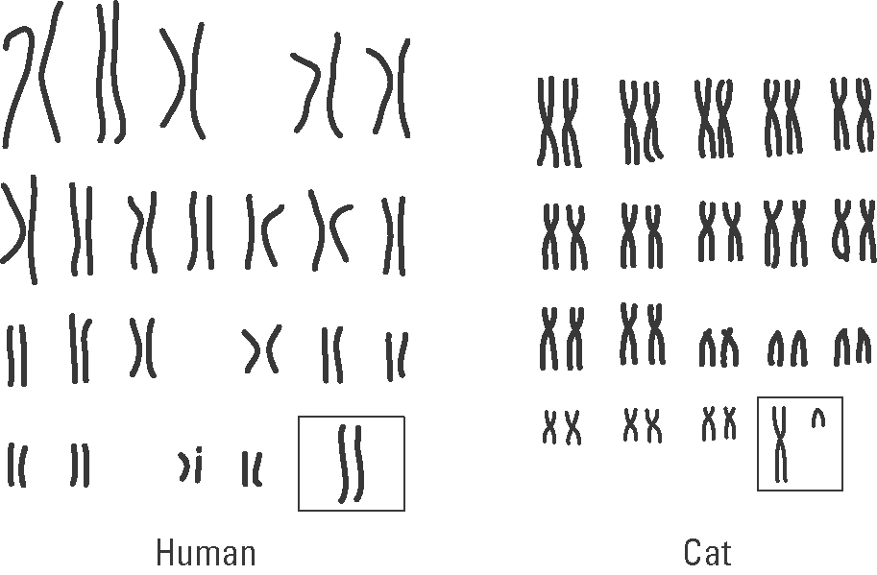
(a) What is happening when chromosomes appear as double strands?
The chromosomes have made copies of themselves before the nucleus and cell divides.

(b) Compare the chromosomal number of humans and cats.
Humans: 23 pairs; Cat: 19 pairs

(c) Determine the sex of the human and the cat.
Human = female as the sex chromosomes are the same. Cat = male as the sex chromosomes are different.

Klinefelter’s syndrome
2. Klinefelter’s syndrome is a genetic disease in males. It leads to reduced fertility due to small testes. These males have poor beard growth, wider hips and show some breast development. The image below shows a chromosomal map for a male with this syndrome.
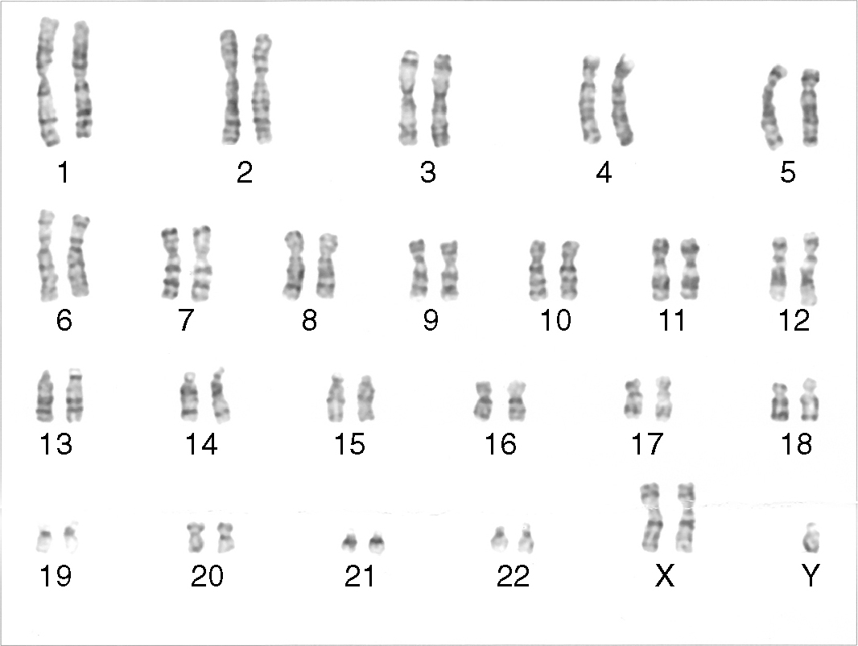
© Nami-ja/Wikipedia
CHAPTER 2: Getting into genes

Worksheet 2.1

Page 2

(a) Use the chromosomal map to identify the cause of this syndrome.
An extra X sex chromosome

(b) Explain the differences in appearance of these affected males to normal males.
The extra X chromosome feminises the male leading to wider hips, breast development and reduced beard growth.

The fruit fly
3. (a) The following diagrams show the fruit fly’s chromosomes for male and female flies.
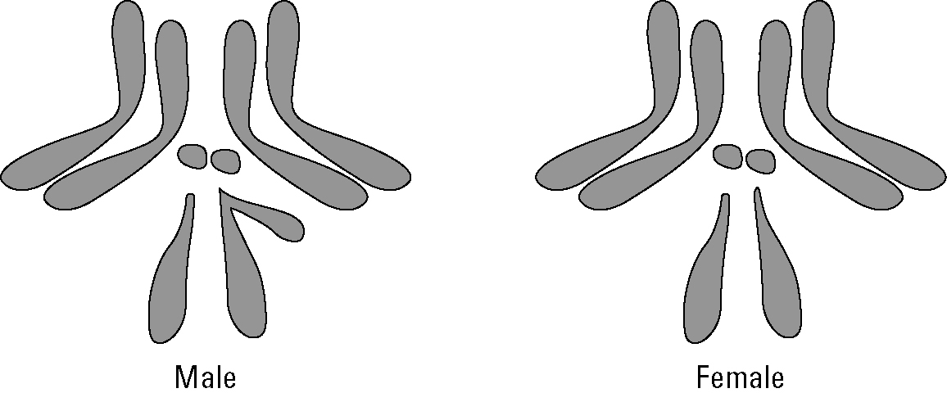
(i) How many chromosomal pairs does this fly have in each cell?
4 pairs

(ii) Suggest why it took scientists less time to decode the genetic code of fruit flies
than humans.
As there are only 4 chromosomal pairs, it is faster to decode the genetic composition compared with other animals with many chromosomes (e.g. a cat or a pig).

(b) Genes on chromosomes may contain abnormalities. Consider chromosome number 2 for the fruit fly.
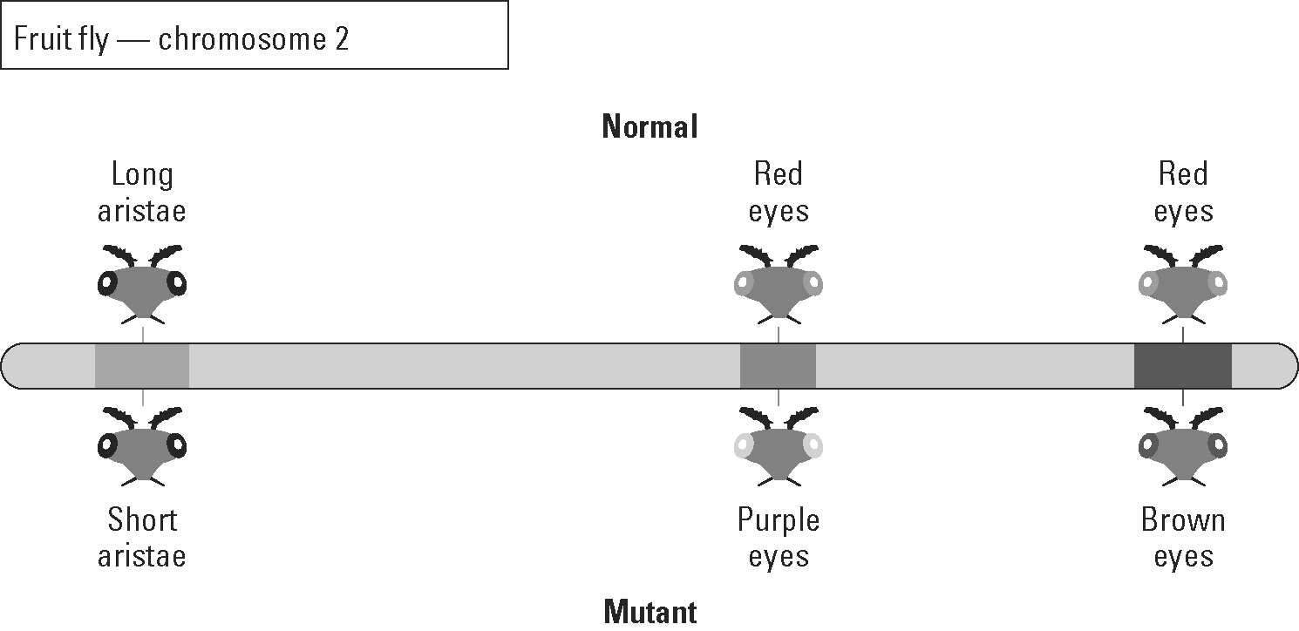
(i) What name is given to gene abnormalities?
Mutations

(ii) Eye colour in fruit flies is determined by more than one gene. True or false?
True

